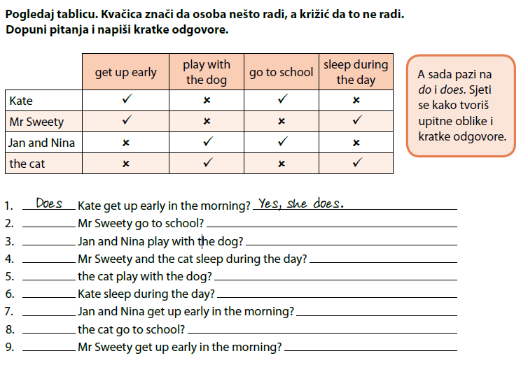

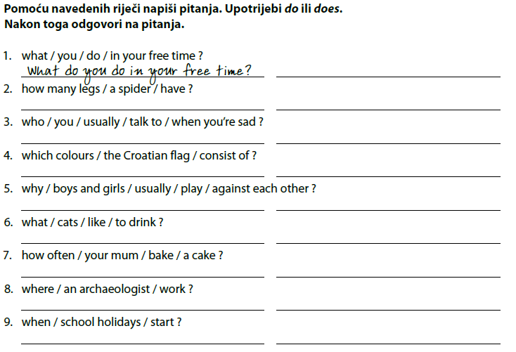

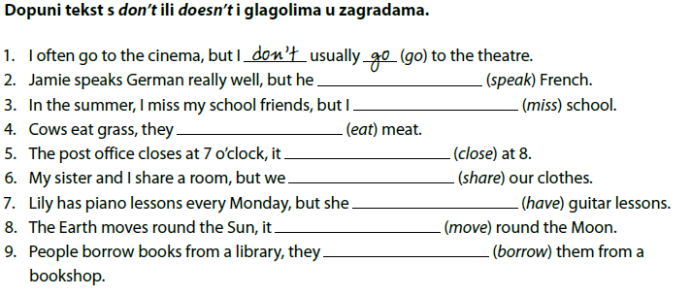
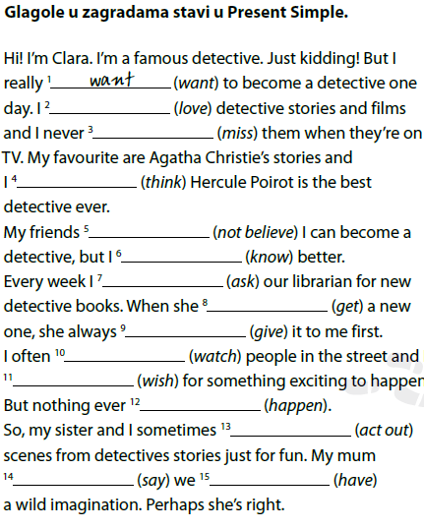

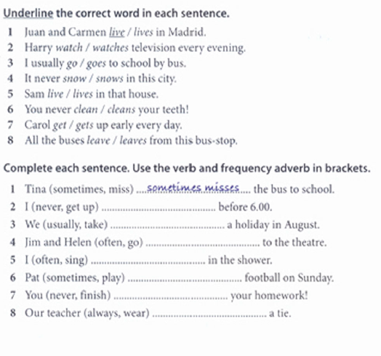

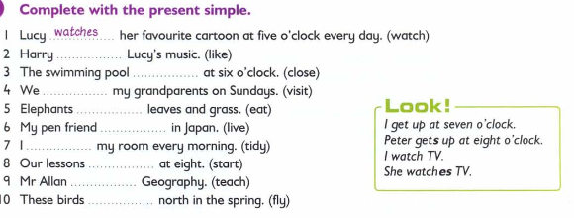

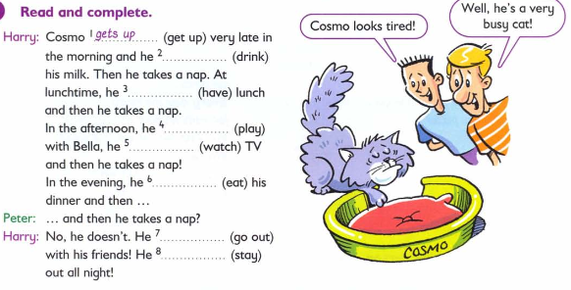
Complete the sentences with the correct form of the Present Simple
- You ___________________ (speak) English.
- Jose ___________________ (not speak) English.
- I ___________________ (play) tennis.
- Karen ___________________ (not play) tennis.
- The train ___________________ (leave) every morning at 8 AM.
- She always ___________________ (forget) her purse.
- Every twelve months, the Earth ___________________ (circle) the Sun.
- Cats ___________________ (like) milk.
- Birds ___________________ (not like) milk.
- The bus ___________________ (not arrive) at 11 AM, it arrives at 11 PM.
- The party ___________________ (start) at 8 o'clock.
- Jenny ___________________ (need) help.
- He ___________________ (have) his passport in his hand.
- You only___________________ (speak) English.
- Once a week, Tom ___________________ (clean) the car.

